Assignment 6

Screen shots

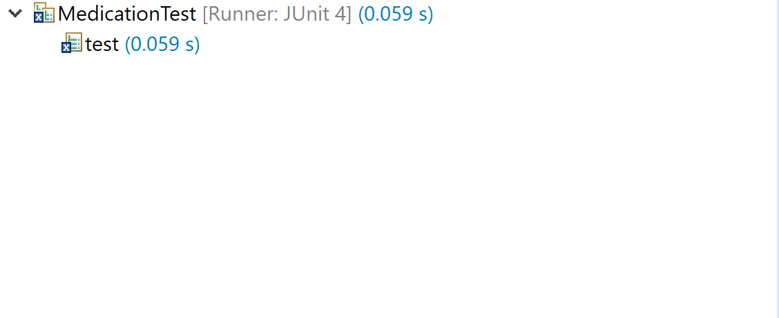

Description: Initial Test using assertEquals() failed.

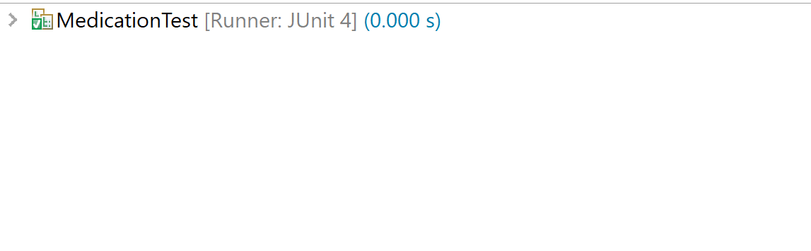

Description: Using assertEquals() to test the setName() and getName()

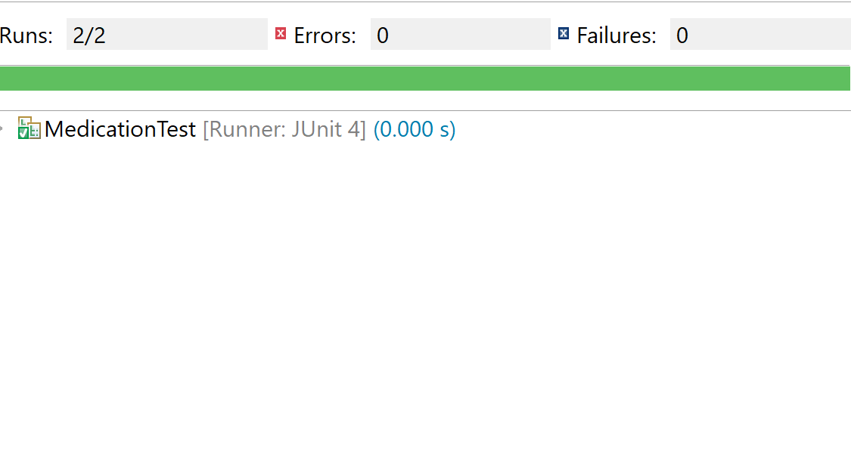

Description: Using assertEquals() to test the setName() and getName() another time to make sure it is working properly.

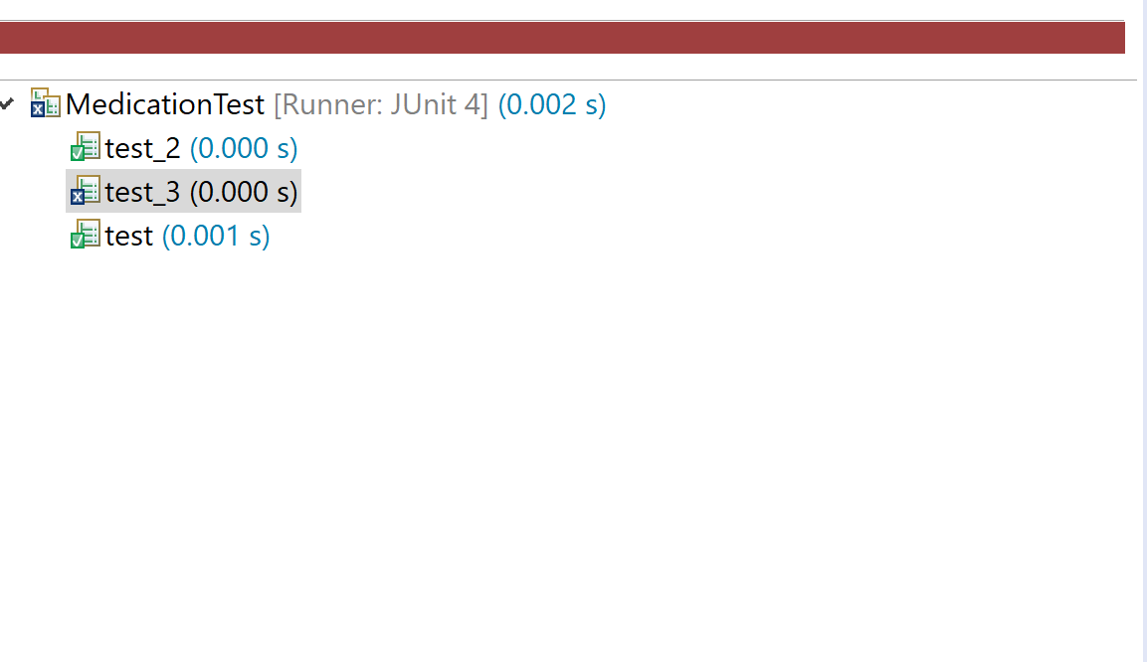

Description: Using assertEquals() to test the setNdc() and getNdc() failed invalid entries.

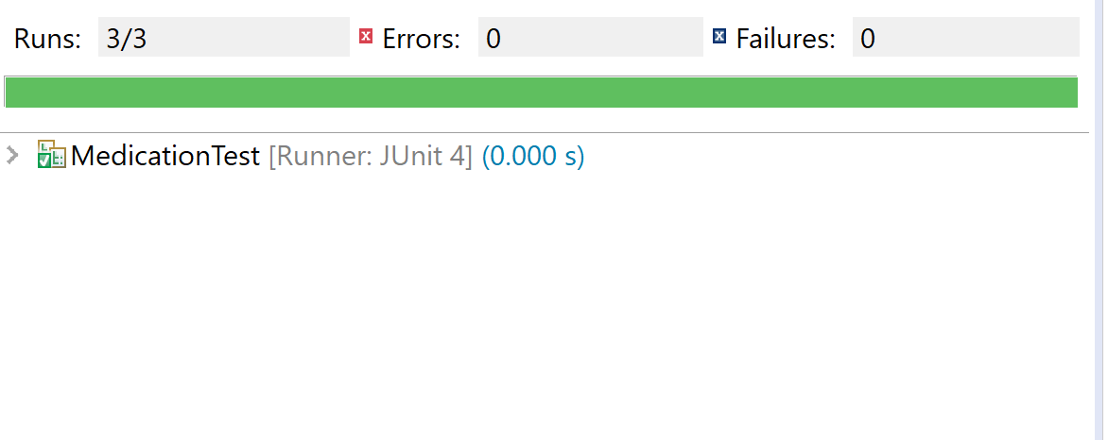

Description: Using assertEquals() to test the setNdc() and getNdc() passed

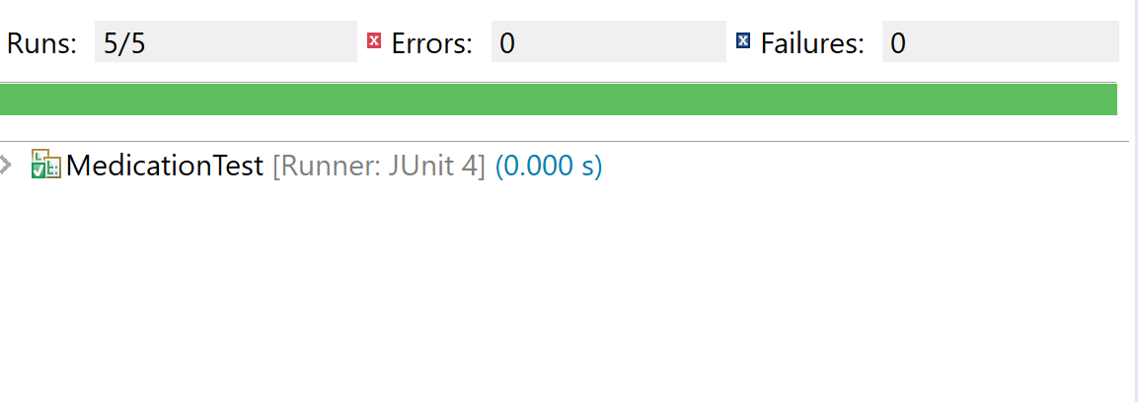

Description: Using assertEquals() to test the setStrength() and getStrength() pass.

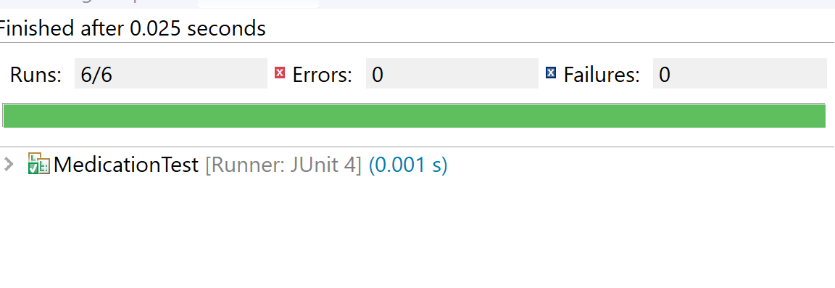

Description: Using assertEquals() to test the setQuantity() and getQuantity() pass

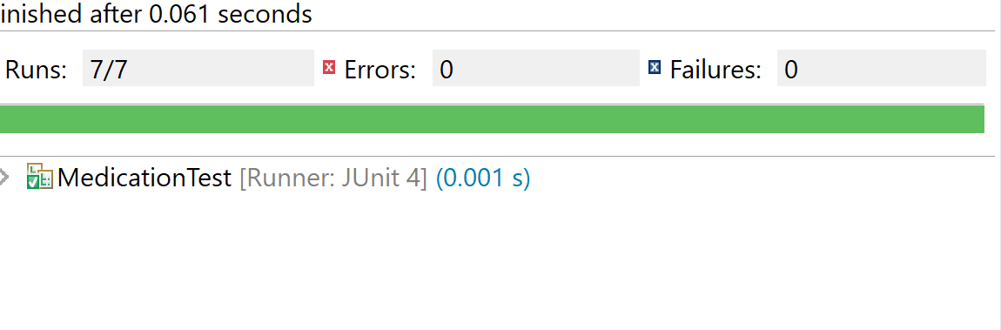

Description: Using assertEquals() to test the setSchedule() and getSchedule() pass.